Class Responsibility Document

Introduction

Conception :
In this project, the overall system is designed to manage different kinds of events by using a general abstract Event class, and several subclasses of Event. These subclasses include Academic, Professional, and Social. It also includes several supporting classes that we’ve deemed necessary which include Organizer, Participant, and Registration to handle event ownership, and attendee registration. The system connects each Event to an Organizer, allowing every event to have a person responsible for managing it. The system also supports event registration through the Registration class and the IRegistrable interface. These together help define how attendees can be linked to events. The main purpose of the system is to be able to provide a clear way of creating events, categorizing them accordingly, assigning organizers to each event, and managing registrations.

UML diagram

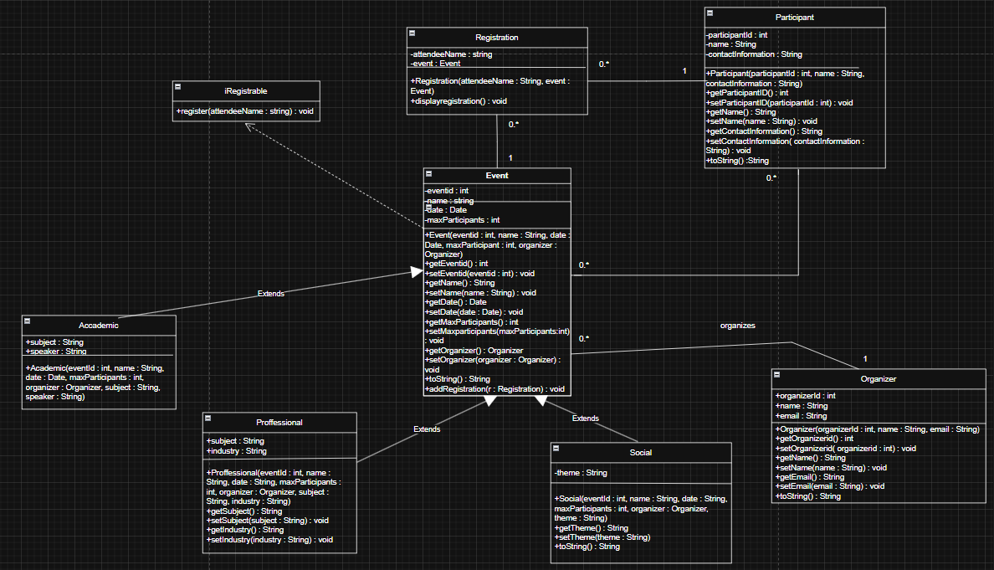

Description :
This UML diagram represents an event management system where the main class is Event, which stores general information such as the eventId, name, date, and maximumNumberOfParticipants. The Event class acts as a base class and is extended by more specific types of events like Academic, Professional, and Social, each adding its own attributes (eg. subject and speaker for Academic events, industry for Professional events, and theme for Social events). The Organizer class is linked to Event with a one-to-many relationship. This means that one organizer can manage multiple events, but each event is organized by only one organizer. The Participant class represents users attending events and is connected to the Registration class, which serves as a bridge between Participants and Events. This allows participants to register for multiple events and events to have multiple participants. The Registration class is responsible for storing information related to each registration. In addition, the iRegistrable interface defines a register method and is implemented by the Event class, showing that events support the registration process. The UML diagram shows the use of inheritance, associations, and interfaces to organize the system.

Class 1: Event

Event is the main abstract parent class for all the event types in our system. Its purpose is to store the common information that every event needs such as the eventId, name, date, maxParticipants, and organizer. It also contains the getter and setters in order to use these attributes in other classes, while maintaining privacy, and the toString() method to override for displaying the event details. We chose to make this class abstract, as it’s not meant to be created directly, but rather extended by more specific event classes (Academic events, Community events, Professional events, etc.)

Class 2: Academic

The Academic class represents an academic type of event, such as a lecture, a seminar, or a workshop. It inherits the general event properties from Event and adds academic event specific details such as the subject, and the speaker. Its role is to model events focused on education.

Class 3: Professional
Professional represents a professional or career related event. It extends from Event and includes additional details such as subject and industry. Its role is to model events such as networking sessions, career fairs, conferences, etc.

Class 4: Social

Social represents a social event in the system. It extends from Event and adds a theme attribute, which is used to describe the social theme, or style of the event. Its responsibility is to manage events that are mainly social and for entertainment, interaction, celebration, etc.

Class 5: Organizer

Organizer is responsible for storing the information about the person responsible for organizing an event. It contains an organizerId, name, and email. Its responsibility is to represent the event manager and connect the organizer to an Event.

Class 6: Participant

Participant is going to represent a person who attends events. Its purpose is to manage attendee details such as participantId, name, and contact information.

Class 7: Registration

Registration represents the connection between an attendee and an event. It stores the attendee’s name and the event they’ve registered for. Its responsibility is to record event registrations, and to provide a method to display the registration information using the displayRegistration() function.

Class 8: Main

Main is intended to be where objects and instances would be created, and the system would be tested or executed. In this iteration, it’s currently empty, so it doesn’t yet perform any actions. Its future responsibility would be to create objects such as organizers, events, participants, and registrations. It’s also going to run the event management system, and to demonstrate how the classes work together in the system. It will also be used to test features of the application, such as creating different event types, registering attendees, assigning organizers to events, printing event information, etc.

Interface 1: IRegistrable
Registrable is an interface that defines a registration behavior. It requires implementing classes to provide a method register (String attendeeName). Its role is to ensure that any class that supports registration follows the same structure and behavior.

Solution

Github link: https://github.com/Sofia-S48/JavaProject

